GrowBro CRM
Instagram & Messenger Integration Guide
Step-by-step process to connect Instagram and Facebook Messenger with a GrowBro AI agent
Purpose: This document explains how to connect Instagram and Messenger to GrowBro CRM so your selected AI agent can handle Instagram DMs and Facebook Messenger conversations automatically.

Before You Start
• GrowBro CRM login access.
• Facebook/Meta account login access.
• Admin access to the Facebook Page and Meta Business Portfolio.
• Instagram account connected to the selected Facebook Page.
• Correct AI agent selected inside GrowBro CRM.

Quick Step Summary
Step | Action | What to Check
1 | Open Integrations and choose Instagram & Messenger | Correct AI agent is selected
2 | Click Connect and log in to Facebook | Use the correct Facebook/Meta account
3 | Continue with the displayed Meta account | Confirm the account name is correct
4 | Select Facebook Page access | Choose the required page
5 | Select Business access | Choose the right Meta Business
6 | Review access permissions | Click Save only after checking permissions
7 | Complete connection | Status should show connected

Step 1: Open Instagram & Messenger Integration
• Go to GrowBro CRM dashboard.
• Open Settings or Integrations.
• Click Instagram & Messenger.
• Select the AI agent you want to connect, for example: bizwit.
• Click Connect.
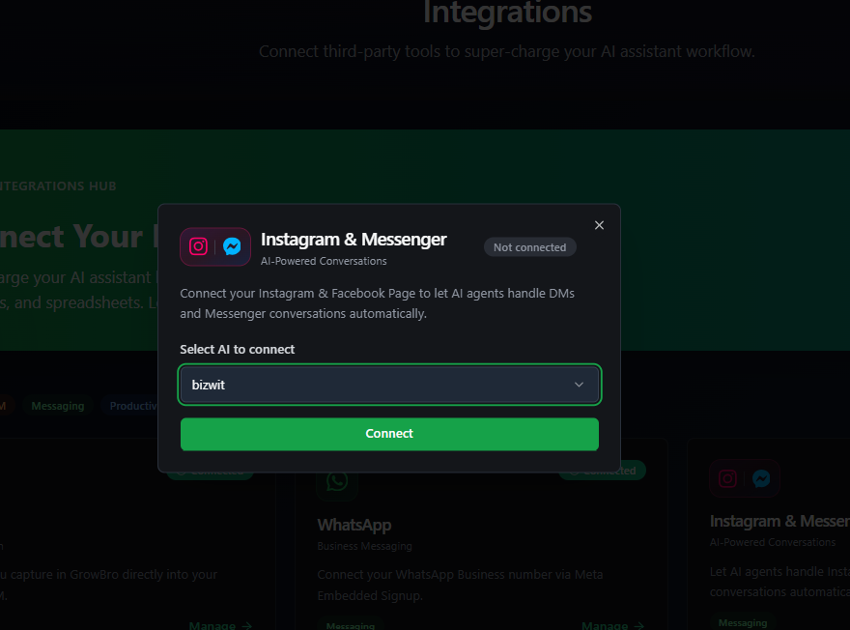
Step 1: Open Instagram & Messenger integration

Step 2: Log in to Facebook
• A Facebook login popup will open.
• Enter the Facebook email/mobile number and password.
• Click Log in.
• Use the account that has admin access to the required Facebook Page and Instagram account.
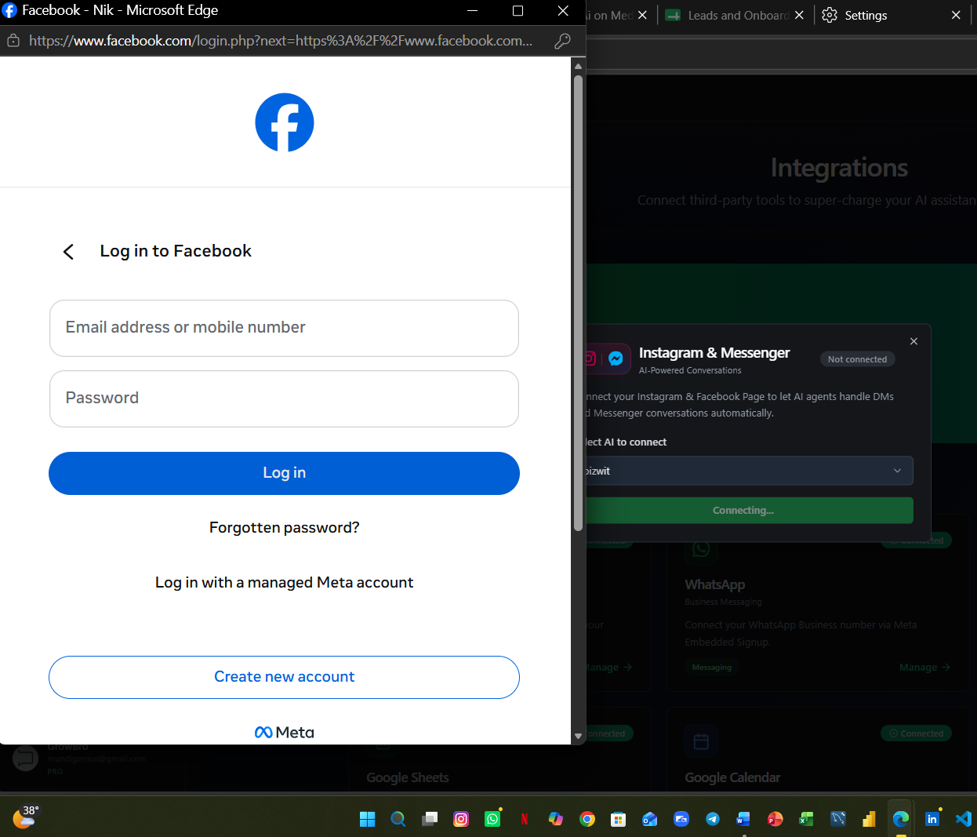
Step 2: Facebook login window opens

Step 3: Continue With the Correct Meta Account
• Facebook will ask to continue as the logged-in account.
• Check the account name carefully.
• Click Continue as GrowBro Ai, or choose another account if needed.
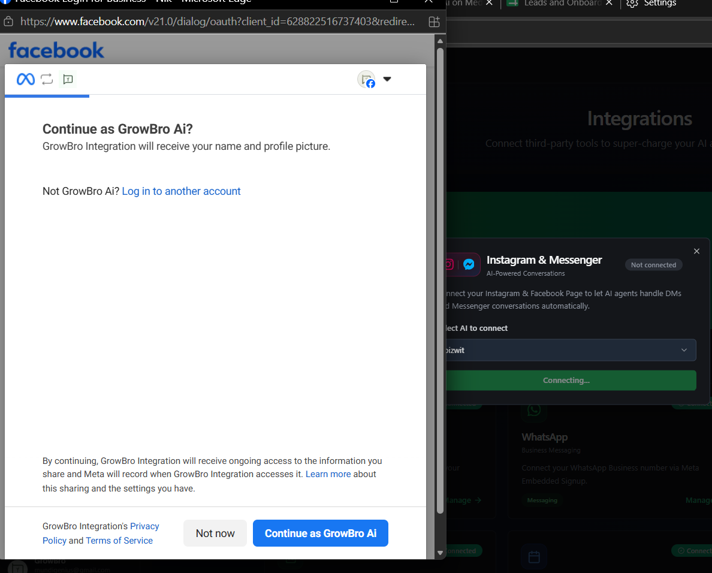
Step 3: Continue with the correct Meta account

Step 4: Choose the Facebook Page
• Select Opt in to current Pages only for controlled access.
• Tick the Facebook Page you want GrowBro CRM to access.
• Click Continue.
• You can select all only when all pages should be connected.
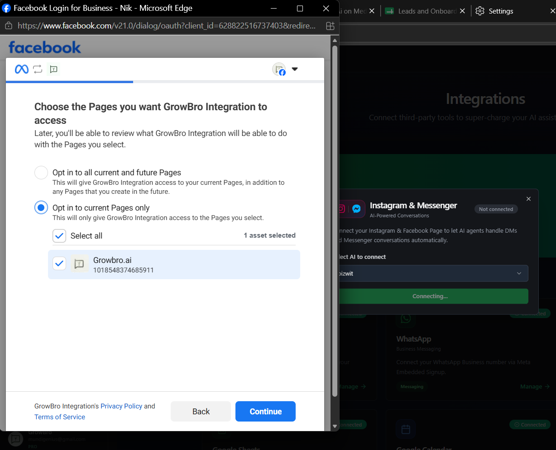
Step 4: Select the Facebook Page

Step 5: Choose the Meta Business
• Select Opt in to current Businesses only.
• Tick the correct Meta Business portfolio.
• Click Continue.
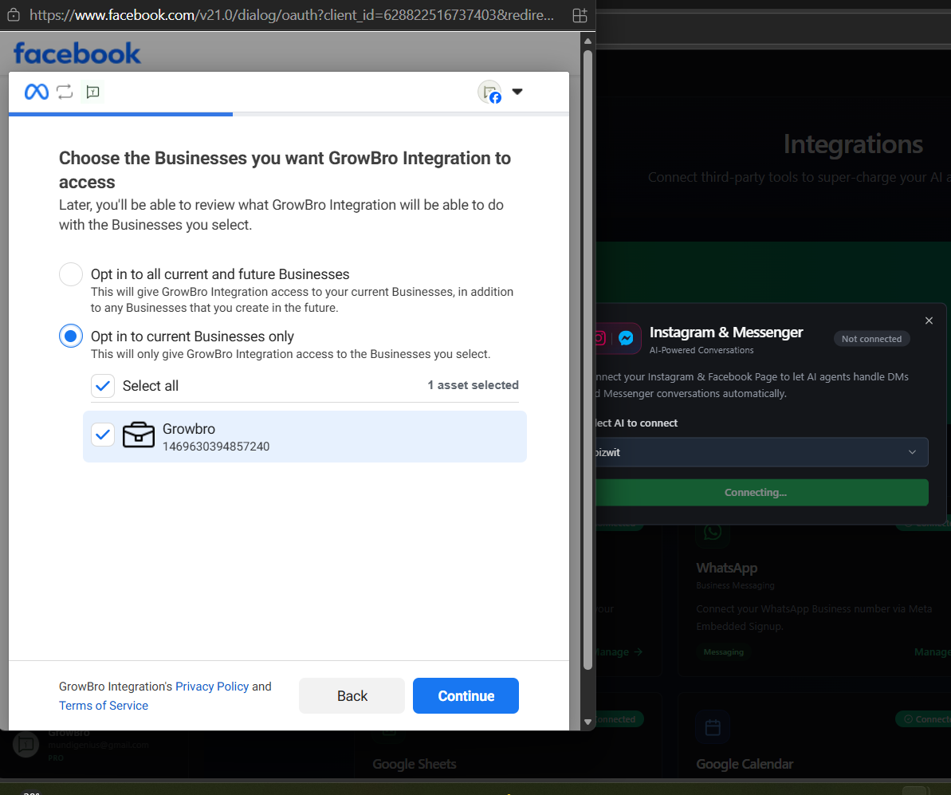
Step 5: Select the Meta Business

Step 6: Review Permissions and Save
• Review all permissions shown by Meta.
• Confirm the selected Page and Business are correct.
• Click Save to allow GrowBro Integration access.
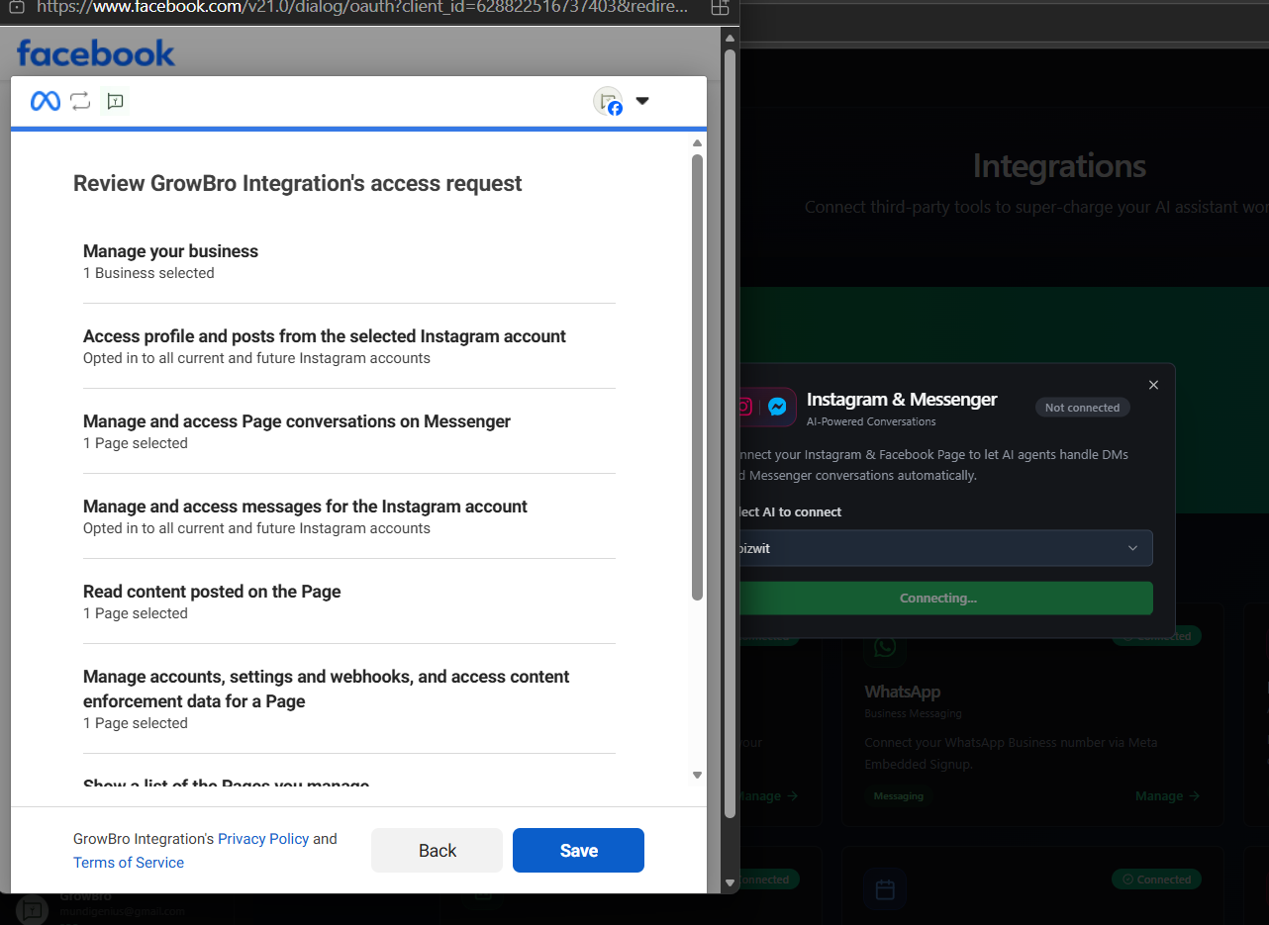
Step 6: Review access permissions and save

Step 7: Finish the Connection
• After saving, Facebook will show that GrowBro Ai has been connected to GrowBro Integration.
• Click Got it.
• Return to GrowBro CRM and wait for the integration status to update.
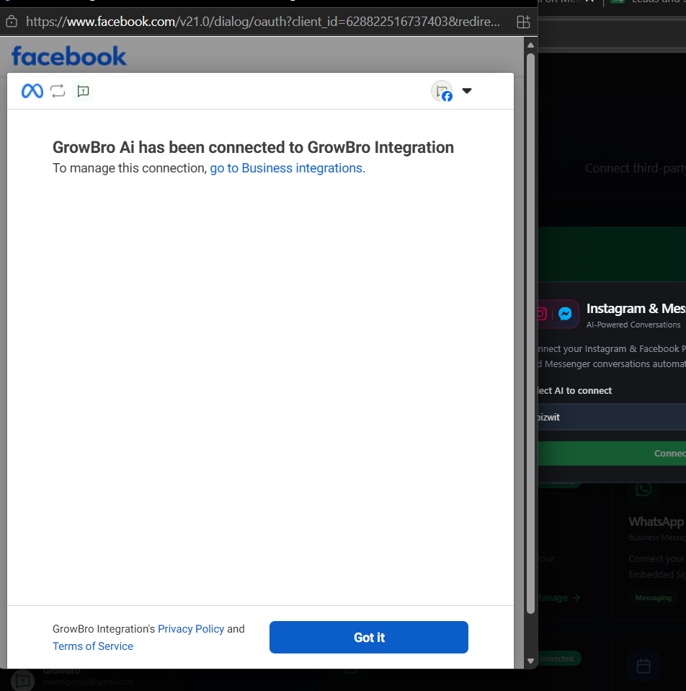
Step 7: Confirm connection is complete

Final Checklist
☐ Instagram & Messenger card shows Connected in GrowBro CRM.
☐ Correct AI agent is selected.
☐ Correct Facebook Page is connected.
☐ Correct Meta Business is connected.
☐ Test message from Instagram DM is received by the AI agent.
☐ Test message from Facebook Messenger is received by the AI agent.

Common Issues and Fixes
Issue | Fix
Facebook login not opening | Allow browser popup and retry Connect.
Page not visible | Check Facebook Page admin access and Instagram connection.
Business not visible | Check Meta Business admin permission.
Connection stuck on Connecting | Refresh GrowBro CRM after completing Meta steps.
Messages not coming to AI | Reconnect integration and test again from another Instagram/Facebook account.

Note: Do not share Facebook passwords, OTPs, or admin credentials in chat. The business owner should complete Meta login and permission approval directly.

